Devil Girl

Press package

Get ready for a ride from hell!
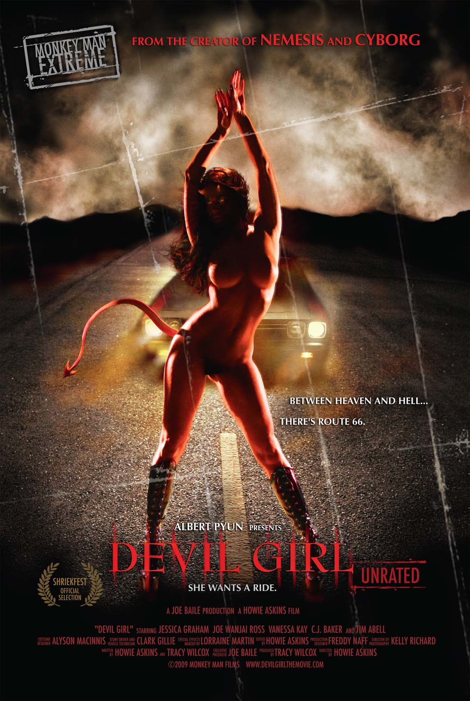

Horns, Tail, and Rock and Roll!!!

Heavy rock and fast cars, punctuate this sexy psychological cult thriller. Just when you think you’ve got it figured out, you’ll skid into another turn.

Devil Girl will take you on a road “trip”.

Synopsis:

FAY is a tough young woman on a soul searching road trip through America on Route 66, drag racing for cash in her late father's '69 Chevelle. After a brief encounter on the road with a mysterious '60 Ford Thunderbird displaying the license plate "goin' down", she has a close call during a race in the form of a near head-on collision with a big rig. Although shaken up, Fay has won again and she continues into the unknown, sad memories of her father still haunting her.
As she zooms down Rte. 66 toward her destiny, a lone motorcyclist speeds out of Las Vegas in the middle of the night. After an all night drive, the bike finally gives and strands the man in the middle of the desert. Removing his helmet, he reveals himself as The CLOWN, a demented man in grease paint whose motives we can only guess. The Clown quickly finds another set of wheels when he unconsciously terrifies the young female driver of an old Volkswagen Beetle and steals the car. He continues on Rte. 66, his path surely to cross with Fay's.
When a biker tells Fay of a "show", she finds herself at a burlesque style dance competition on Rte 66. Women of a variety of shapes and sizes dance and perform scantily clad in a tribute to classic alternative American culture.
As Fay gets back under way, The Clown finds himself walking again, the Beetle having given in to the desert heat. Pulling a gun from his leather jacket, he attempts to rob a random gas station with the intent of taking the attendants car. When this doesn't work out he knocks the attendant unconscious and raids the stores liquor and candy while simultaneously popping pills. It's at this moment that a pretty young girl happens to drop in in an old Ford pick-up. The Clown, high as a kite, fantasizes that he and this unfortunate girl are acting out a porno scene on television. What happens in reality we can only guess.
Now Fay, low on gas, pulls into the station for a fill up. Upon entering the store she finds no sign of anyone. Meanwhile the Clown has snuck out and is stealing her wallet and cash from her front seat. He then steals the pick-up, the sound of it's engine prompting Fay to walk outside. As the pick-up pulls away down Rte. 66, Fay again sees the mysterious Thunderbird following behind him. She leaves the gas station, forgetting to fill up.
The Clown it seems just can't get a break. Now the pick-up breaks down, leaving him stranded on the highway, dazed and confused. The Thunderbird materializes out of nowhere and picks him up. Devil Girl is at the wheel, red-skinned, horned & sexy. They share a joint and fly off into the flaming desert sky.
The next morning the Clown wakes up along the highway. Did last night really happen? He steals a bicycle and continues down the road still lost in his crazy daydreams.
When another muscle car pulls up next to her and challenges her to a race, Fay obliges. The race is brief because Fay runs out of gas and now becomes stranded. She grabs a few of her belongings and hoofs it up the road.
The Clown and Fay arrive simultaneously at a mechanics shop in a local town where the Clown becomes immediately obsessed with Fay. Fay arranges for her car to be towed and stored at the garage and then heads over to the local sleaze motel. Having no cash, Fay is forced to give her father's gold ring to the creepy motel clerk, BUSTER, as collateral for her stay. Once in her room Fay cleans up and has a brief encounter with her father's ghost...
Fay heads out looking for a way to scrape up some cash. Turned down at the local diner, she is directed to the "Burning Bush" a strip club across the street where she reluctantly takes a job as a dancer.
Back at the gas station, the Clown breaks into the bathroom looking for a place to sleep for the night. Laying on the concrete floor, he pulls out Fay's license and gazes at it longingly.
Fay arrives at her motel room exhausted, a little humiliated from her dancing experience but not without a decent grip of cash. From her television an evangelist shouts out cryptic passages as Fay drifts into sleep. She dreams briefly of a funeral before jolting awake with the sense that someone is in the room. Her blankets, for some reason, are off her bed and in the corner of her room. Fay eventually goes back to sleep.
On her way to breakfast the next morning, Fay meets the town preacher, a charming but overbearing man who suggests Fay join his congregation. From their conversation we learn that "Fay" is short for "Faith" and the preacher later uses this play on words in an impromptu sermon to Fay and the locals in the diner.
Fay goes to the mechanics shop to check on her car and discovers she needs a new fuel pump or she isn't going anywhere. Worse yet, the mechanic informs her that he won't be able to get the necessary parts until next week.
Fay returns to her motel room to discover Buster exiting her room. He claims that he was bringing her fresh linens but we can see a pair of her panties sticking out of his back pocket.
Later that night outside the Burning Bush, the Clown smokes a joint and slips the doorman a couple bucks before entering. Inside the place is alive with dancing girls and a live band. The Clown begins to hallucinate again- a cocktail waitress becomes a zombie, the cage dancer is covered in blood and screaming, and a trio of Pig-men cheer on the topless dancer onstage. Suddenly the lights go down and the Clown finds himself in his own world, with Devil Girl giving him a sexy strip tease.
Once back to reality, Fay takes the stage and the Clown is thrilled with her performance. Fay on the other hand is creeped out by the Clown and she again gets a glimpse of her father's ghost as she does her strip tease. The bouncer, RANDY, decides he doesn't like the Clown and throws him out before giving Fay a ride to her motel.
Fay flirts with Randy a bit before leaving his car. In her room, Fay again gets the sense that she isn't alone as the television evangelist rants on. She discovers the Clown at her window and becomes frightened. He leaves though and she drifts off to sleep clutching a screwdriver for protection. Once she is asleep, a large leather masked man seems to materialize in her room and attacks her in her bed, raping her mercilessly before disappearing into the darkness. Was her attacker an apparition or demon?
The next morning the preacher is giving his sermon to the townsfolk when the Clown suddenly interrupts him by farting in the pew and telling dirty jokes. After making quite a scene the Clown storms off. Once outside he has a brief hallucination of Fay as an angel.
Fay arrives at the Burning Bush for her shift and does a tequila shot. Two sexy girls are dancing together on stage when the Clown enters. Fay takes the stage to do a dominatrix type performance and she becomes emotional and kicks the Clown in the head. Randy immediately throws him out again.
Backstage Fay breaks down, seeing things in the shadows and sobbing. She leaves the Burning Bush to discover Devil Girl waiting for her outside with her Thunderbird. They drive away and Devil Girl seduces Fay into having sex with her in the back of the car.
Meanwhile in the gas station bathroom, the Clown has a sort of breakdown of his own. He stares hauntingly into the mirror as he pops pills, drinks liquor and refreshes his make-up.
Alone in the town church, the preacher is visited by Devil Girl who appears nude beneath the cross. Devil Girl accuses him of dark deeds and berates him for his hypocrisy before murdering him with her tail. The preacher wakes up on the church floor to realize Devil Girl has visited him in a dream.
Fay has a dream of a happy day where everything is ok now and she is finally leaving town. When Devil Girl appears in her dream, Fay wakes up. She has the cash she needs now to get her car and pay off Buster to retrieve her father's ring. Buster explains to her that he gave the preacher the ring to hold for safe keeping and that she needs to see him at the church to get it back. Frustrated, she storms off to the church.
She arrives at the church to find no one there. She hears faint cries coming from behind a door in the back of the church and follows the sounds into the darkness. To her horror, she finds a young man nearly nude and caged up in a corner. The preacher shows up behind her wearing a leather mask--the face of her rapist! He knocks her nearly unconscious and attempts to chain her up but she stabs him in the crotch with a screwdriver she was carrying in her pocket. She strikes him with a club, killing him. She releases the young man and carries his trembling body out of the church.
As they are exiting the church, Buster is pulling in with his Mercury Cougar. Fay hides herself and the young man behind some bushes. She watches Buster enter the church and suddenly leave with murder in his eyes. She runs the other way when suddenly a sheriff’s car pulls up. The young man runs to the sheriff, leaving Fay unsure of what to do. Out of nowhere, the Clown appears on a motorcycle. He offers a ride which she accepts and they speed back to the motel.
At the motel she grabs a couple of her bags and begs the Clown for a ride to the mechanic's to get her car. He races her there, where she finds that the mechanic is out to lunch. In a panic, knowing that Buster is looking for her, she finds her keys and fires up her engine. She pulls away but stops a moment when she sees the clown. He babbles to her, trying to express his feelings when she sees Buster's car approaching over his shoulder. She spins out and speeds away leaving the clown literally in her dust.
Fay races through the desert at well over 100 mph but it isn't enough. Buster's car is faster and he rides her bumper. He pulls a gun, cocks it and pulls up beside her. He just has her in his sights when the Clown pulls up on the motorcycle and knocks the gun from Buster's hand, sending Buster into a spin out. Fay speeds away looking back at the action. When she faces forward, she realizes she is speeding head on into a big rig...
At the mental institution, the Clown comes to from his elaborate fantasy. He is now wearing no make-up. Some of the townspeople are also in the institution...and Fay is a nurse who informs him that today is the day he gets to go home.
Back in the fantasy world, we find the preacher is crucified, bloody, on his own cross. Devil Girl pulls away in her Thunderbird, driving off into the sunset.

About the Cast…

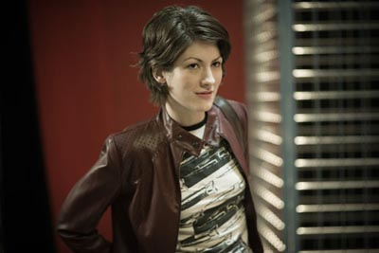

Jessica Graham (Fay) has starred in two feature films since her 2005 arrival in Los Angeles. Jessica has played the lead role of Fay in Devil Girl, as well as the lead role of Abigail in the film Two Minutes. This Philadelphia native has appeared in numerous stage plays, independent feature films, and commercials. Like her character Fay, Jessica also drove across the country to pursue her acting career.

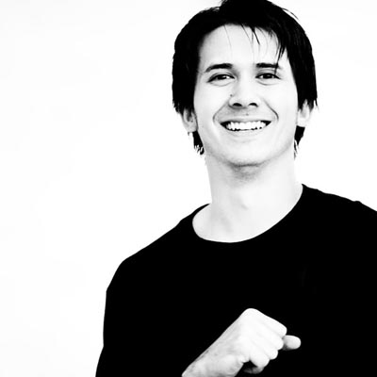

Joe Wanjai Ross (The Clown) hails from Kansas City, Missouri. He got his start in New York, studying under acclaimed acting guru, Susan Batson. Joe is also a screenwriter, having written 15 feature-length screenplays. Joe is happy to be making his feature-starring debut in Devil Girl.

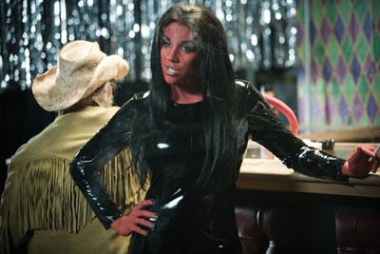

Vanessa Kay (Devil Girl), a Southern California native decided to pursue her dream of acting after studying psychology at Mt. San Antonio College. Vanessa then moved to Los Angeles where she studied acting at Playhouse West. Although, her big break was landing the lead Juggy role on The Man Show, Vanessa has also been featured on; The Andy Dick Show (MTV), & Greg the Bunny (Fox). Vanessa has graced the covers and pages of numerous calendars and magazines. Devil Girl is Vanessa Kay’s debut title role.

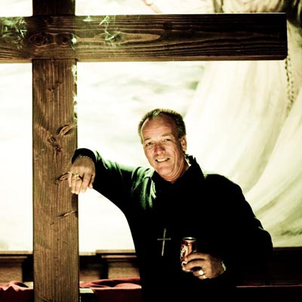

C.J. Baker (Preacher) has been acting on stage since the age of 15. He has since landed lead and supporting roles in over 50 stage productions. Most recently he received the Drama-Logue “Best Actor” award for his role as Lt. Joe Adams, in the critically acclaimed production of “The Visit”. Since 2004 C.J. has been in seven independent films. C.J. is working on his first screenplay, a spectacular World War II epic based on the true story of how one man’s courage and determination paved the way for victory in the Pacific theater.

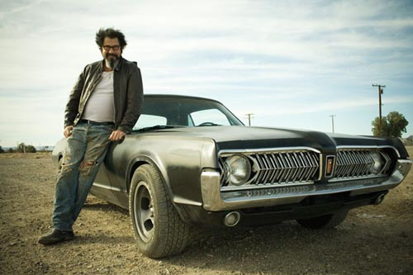

Jeff Swarthout (Buster) moved from Hell’s Kitchen, New York and thinks Devil Girl rocks! Most recently Jeff played “Park John” in Garden’s of the Night, starring John Malkovich and Evan Ross. Jeff can also be seen in The Flesh Keeper, Trail of Crumbs, Quick and the Undead, Valley of Angels, and Demonica.

THE CREW

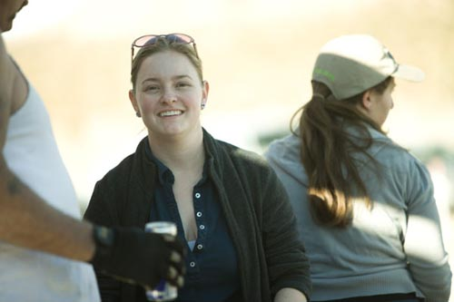

KELLY RICHARD (Director of Photography )

Born in Tucson, Arizona, Kelly graduated from the Cinema-Television Production program at the University of Southern California in 2001. She began her career as a film loader, and quickly worked her way up though the camera department; assisting, pulling focus & operating on over fifty feature films and numerous other projects. By 2005, she began working consistently as a director of photography and has since collaborated as the cinematographer on nine feature films, three documentaries, seven comedy specials for the LOGO network and dozens of commercials, shorts, music videos, and PSAs. Kelly also often shoots corporate videos, behind-the-scenes featurettes, and live events such as the Pasadena Tournament of Roses Rose Bowl and Rose Parade and events for the Academy of Motion Picture Arts & Sciences. Several of her independent features will be released this fall, including Devil Girl, Live Evil, and the family-oriented noir style mystery Freaky Faron. Most recently, Kelly wrapped principal photography on the first two episodes of the TV series In The Room.

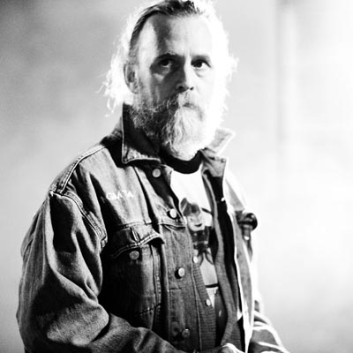

BILL BRYAN (Special Effects) began designing, building, and performing effects when he was in high school. A BFA from Syracuse University’s School of Visual and Performing Arts and a trip across the country, hitchhiking and hopping freights led to his first job in NBC’s Wardrobe Department where he created costumes and puppets for TV, Films and Commercials. Meanwhile he was appearing in Shakespearian productions at Will Geer’s Theatricum Botanicum. Since then he has built costumes and performed for films, such as: The Staypuft Marshmallow Man for ‘Ghostbusters’, Grouchy in ‘Men in Black’, the robot in ‘Bicentennial Man’, a big ape in ‘King Kong Lives’, pteranodons in Jurassic Park 3. He built Stillsuits for ‘Dune’, shells and parts for ‘Teenage Mutant Ninja Turtles 3’, creatures for ‘The Outer Limits’, ‘Poltergeist’, ‘Stargate’, Fat suits for ‘Frasier’ and others, plastic outfits for Primus, Duracell, and Fosters. His work has graced commercials for Energizer, Miller Lite, Magix Cards, and Nissan. He has made puppets for 'Species', 'Rex', 'Sabretooth', 'Amityville 2', 'The Gate 2'. He has made Set pieces for ‘Overboard’, ‘Spaceballs’, ‘Die Hard’, ‘The Naked Gun’, ‘Toys’, ‘Hook’, ‘Honey I Blew up the Kid’, Madonna Videos, ‘The Cat in the Hat’,
‘Baby Boy’, ‘Spiderman 2’, Epcot, and more. Bill’s Reel can be seen on Youtube.com at 'Bill Bryan's FX Video'.

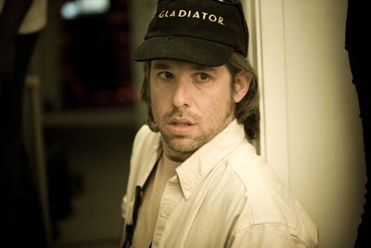

Barry Caldwell (Script Supervisor) has over three decades of experience in the music,film and television industries. He recently directed and producedthe short thriller Send in the Clones, which screened at the Dances with Films Festival. He also directed and produced the multiple award-winning supernatural suspense thriller Reflections. Other projects Caldwell has produced include the short fantasy Night’s Necromantic Rose, which played the festival circuit in 2004 and
2005, as well as the short film Rigor Mortic Dreams. His directing experience also includes the Michael Mulholland music videos for Candy Coated Kisses and As Good As It Gets. As a script supervisor, he has worked with famed filmmakers Quentin Tarantino, Ivan Reitman, Eli Roth, Vicky Jenson, Allison Anders and Miguel Arteta. He has been a part of numerous low budget horror & thriller productions, including Cabin Fever, Willard, Devil Girl, The Hillside Strangler and Death Row. Inaddition to genre features, he has worked on such festival and art house hits as Sugartown, Skills Like This and Bug. His television credits include CSI, Alias, Eli Stone and Ugly Betty. He is currently editing the documentary feature Standing on the Tracks, which he also produced and directed. http://www.facebook.com/safehousefilms

About the Director…

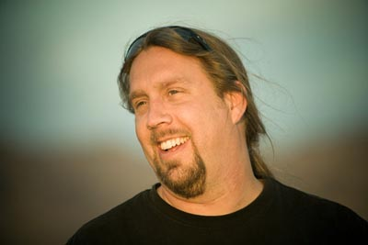

Howie Askins Raised on a farm in rural upstate New York, comic books and dusk till dawn drive-in movies became nourishment for Howie's creative needs at a very young age. Films like "The Thing", "An American Werewolf in London", and " Clockwork Orange" would resonate with him the rest of his life. He first got his hands on an 8 mm movie camera at age 12, and it would be only a few years later that Howie would win his first film festival.

One of Howie's most recent shorts "The Donation" a dark comedy about a lonely woman looking to be impregnated, swept the Extreme 48 Hour Film Festival in Hollywood, California, taking both the audience and jury awards. Another recent short film, "Shifting", a horror flick about a man who believes he is a werewolf, played festivals around the world, it's modest success providing the creative spark for Howie to undertake his feature "Devil Girl", a fantasy/thriller set on a twilight zone-ish Route 66.

Howie has directed a variety of short films, commercials, and music videos and his directing skills were sharpened by wearing a variety of hats in the production world including cinematographer, editor and writer.

Directing, however, has always been Howie’s true love and more feature projects are in the works: There's "Mercy", an intense horror/thriller about a family terrorized by a sadistic con who invades their farmhouse. Also, "Spin the Bottle", a darkly comedic thriller about a kinky married couple who happen to be serial killers and swingers. Then there's a sequel to Devil Girl...a story about a young woman who smuggles drugs from chicago to Los Angeles and eventually gets caught up in the world of porn.

MUSIC BY:

Scum of the Earth

400 Blows

The UV’s

Blare Bitch Project

Sefton

Listing Ship

Ronn Crowder

Orgone

The Walking Dead

Ella G’Sell

Ryan Taylor

CAST

Fay Jessica Graham
Clown/Donald Joe Wanjai Ross
Devil Girl Vanessa Kay
Preacher C.J. Baker
Buster Jeff Swarthout
Cowgirl Alissa Archer
Sammy Jimmy Low
Priscilla Willow Hale
Jesus Ruben Terrones
Gus the Gas Guy Tommy Beaumont
Blasie Kai Cofer
Randy Ben Buschel
Gas Attendant Dorian Martin
T.V. Evangelist/Doctor Jonathan Earl Peck
Bar Owner Keith Lewis
Cocktail Waitress Hope Taylor
Father Tim Abell
Sheriff Tim Moore
Eddie Joshua Roberts
Cheryl Jessica O’Dowd
Sister Elina Madison
Bug Girl Lauren Gribble
Bicyclist Carlos Larkin
Strip Club Band The U.V.’s
Pastor Lightfoot Joe Boyd
Biker Greg Fallert

Burlesque Performers

Miss Indigo Blue
Lucy Fur
Jami Deadly
Adonna Vichet
Lady Ace
Vienna Le Rouge
Scarlet Sinclair
Diamond Back Annie
Hot Pink Feathers
Sabina Kelley
Von Livid
Peekaboo Pointe
Lili’s Burlesque Revue
Wau Wau Sisters
Charlotte La Belle Araignee
Satan’s Angel
Donna Vieira
Bunny Luv

The Flock
Patrick Williams
Bobby Jacquez
Johnny “Pops” Martin Sr.
Jazmin Valentina
Phil Holland
Marty Boger
Serena Sudol

Mac Paul Linne
Main Stage Stripper Stacy Burke
Backstage Stripper Mya Luanna
Lead Singer/Guitar Mia X
Bass Player Blare Bitch
Lead Guitar Johnny Volatile
Drummer Chase Manhatten
Cage Dancer Davia Ardell
Pig 1/Patron 1 Butch Laxa
Pig 2/Patron 2 Mike Bayouth
Pig 3/Patron 3 Steve Muck
Girl in Glass Cage Natalie Minx
M.C./ D.J. Freddy Naff
Bandanna Patron Chris Amesquita
Strip Club Patrons Jeff Susca
Marshall O’Dell
Dave Holzman
Brian Louie
Two Strippers Mya Luanna
Natalie Minx

Oil Drummer Greg Looney
Oil Drum Dancer Lauren
Stunt Coordinator Keith Lewis
Buster’s Stunt Driver Clark”Stuntkok” Gillie
Clown’s Stunt Rider Chris Martin

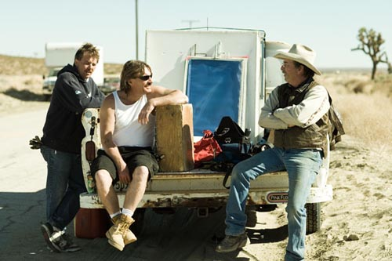

KEY GRIPS Johnny Martin Jr, Marty Boger and Johnny Martin SR. 3 of the best there are!
CREW

Directed by Howie Askins
Produced by Tracy Wilcox
Executive Producer Joe Baile
Screenplay by Howie Askins & Tracy Wilcox
Director of Photography Kelly Richard
Production Designer Freddie Naff
Film Editor Howie Askins
Casting by H.J.T
Unit Production Manager Mark Bashian
First Assistant Director Rhys Summerhayes
Second Assistant Director Mark Bashian
Sound Designer Rob Arbittier
Costume Designer Alyson Macinnis
Devil Girl Make-Up Lorraine Martin
Creative Consultant James Mercs
Art Director Natalie Brun
Set Decorator Noel Naff
First Assistant Camera Phoebe Kruegar
Second Assistant Camera Jason Lamar
Additional Second Assistant Camera Noel Naff
Camera Loader Jason Lamar
Pilot Victor Hobbs
Still Photography Phil Holland
Script Supervisor Barry Caldwell
Supervising Sound Editor
Re-recording Mixers Noisy Neighbors
Production Sound Mixer Eugene Thompson
Boom operator Tom Lowe
Video Camera Operator Troy Manning
Gaffer Johnny Martin
Electrician Vreje Bakalian
Key Grip Johnny martin
Best Boy Grip Marty Boger
Dolly Grip Marty Boger
Grip Jonathon Martin
Grip Intern J.R. Meherin
Property Master Noel Naff
Special Effects Coordinator
Wardrobe Supervisor Jazmin Valentina
Key Make-up Artist Tracy Wilcox
Make-up Artist/ Hair Stylist Stacey Miller
Associate Make-up/Hair Stylist Serena Sudol
Additional Hair Stylist Janet Walker
Additional Devil Girl Make-up Suzi Kim
Rocky Faulkner
Special Make-up Effects Artists Kazu
Gage Kaneka
Alex Aguayo
Tracy Wilcox
Prosthetic Design and Fabrication Tom Devlin 1313fx
Additional Prosthetic Design and Fabrication Paul Thompson
Head Puppeteer/Tail Fabricator Bill Bryan
Creative Consultant James Mercs

Stunt Drivers Joe Baile
Clark “Stuntkok” Gillie
Chris Martin
Freddy Naff
Noel Naff

Stunt Vehicle Technician Clark Gillie
Vintage Vehicles JB’s Car Club
The Creeps Car Club
The Jerks Car Club
Additional Cars Cinema Vehicle Service
Harley Davidson Provided by Scott And Danny of Antelope Valley Harley Davidson
Frankenbike Provided by Blackie Kestor
Additional Camera Supplies Woodland Hills Camera
Lighting Equipment Leonetti Company
Walkies Coffey Sound

Big Rig Provided By John Matthews
Big Rig Driver John Matthews
Title Art/Poster Art Andrew Robinson
Production Coordinator Kari Svendsboe
Production Accountant Carolyn Jennings
Assistant Accounting Karin Sampson
Payroll Accountant Melly Lindsay
Payroll Company Payday Inc.
Post Production Accountant Carolyn Jennings
Attorney Michael Harris
Insurance Campbell and Associates
Location Manager (Palmdale) Mike Baile
Four Aces Manager (Palmdale) Larry
Roy’s Manager (Amboy) Jack Marcus
Blarney Cove Location Paul Linne
Second Second Assistant Director Westley Denton
Extras Casting Eleven Two Seven Casting
Unit Publicist Annemieke Schoof Wilcox
Set Decorator Clark Gillie
Story Board Artist Mike Bayouth
Web Master Sharon Fullerton
Web Designer Phil Holland
Web Developer Jim Gillie
Researchers
Transportation Coordinator S.W. Helena
Production Vehicles Provided by King Kong Production Vehicles
AVON
Security Provided By Pierre
Craft Service/Catering Provided By Dani Kahn
Marty Rudi
DVD Authoring Butch Laxa
24 Frame Video Playback Troy Manning
Assistants to Joe Baile J.R. Meherin
Chris Martin

Production Assistants

Key Set Production Assistant John Clarkson
Set Production Assistant Joe Abramo
Office production Assistant Kari Svendsboe
Production Assistant Lauren Gribble
Post Production Supervisor Parker
First Assistant Editor Chuck Byler
Re-recorded at Noisy Neighbors
Executive in Charge of Music Tracy Wilcox
Composer Rob Arbittier
Guitar Amplifiers Provided By Divided By 13
Percussion Score By Chuck Byler
“Clown Porn” and “Burlesque” Composed by Sergio Rios and Dan Hastie
Oil Drum Provided By Brian Grillo
Titles and Optical Howie Askins
Optical Effects Sharon Fullerton
Title Art Andrew Robinson
Motion Graphics Chuck Byler

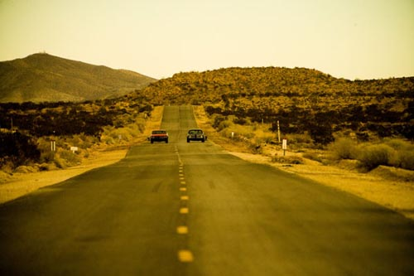
SONGS

“Bloodsuckinfreakshow”-
Words and Music by Scum of the Earth
© 2004 Eclipse Records,Inc.
(p)2004 Scum of the Earth (ASCAP)

“Drink” –
Words and Music by Blare Bitch Project
©2005 Steel Cage Records
(p) 2005 Blare Bitch Project (ASCAP)

“Root of Our Nature”
Words and Music by 400 Blows
© 2003 Rehash Record
(p)2003 400 BLOWS (ASCAP)

“Five“
Words and Music by Sefton
©2006 Sefton
(p) 2007 Sefton (ASCAP)

“The Key (A Barroom Reunion)”
Words and Music by Ronn Crowder
© 1997 Altus Records
(p) 1997 Ronn Crowder(ASCAP)

“Dance Class Revolution”
Words and Music by Listing Ship
© 2002 True Classic C.D.’s
(p)2002 Listing Ship (ASCAP)

“Nothing Girl”
Words and Music by Scum of the Earth
© 2004 Eclipse Records, Inc
(p) 2004 Scum of the Earth Music (ASCAP)

“Mosquito Girl”
Words and Music by Listing Ship
© 2002 True Classic C.D.’s
(p)2002 Listing Ship (ASCAP)

“Make a Wish”-
Words and Music by 400 BLOWS
© 2005 Gold Standard Lab
(p) 2005 400 BLOWS (ASCAP)

“Three”
Words and Music by Sefton
© 2006 Sefton
(p) 2007 Sefton (ASCAP)

“Four”
Words and Music by Sefton
©2006 Sefton
(p) 2007 Sefton (ASCAP)

“Six“
Words and Music by Sefton
©2006 Sefton
(p) 2007 Sefton (ASCAP)

“Down So Long”
Words and Music by Ronn Crowder
©1997 Altus Records
(p) 1997 Ronn Crowder Pub.(ASCAP)

“Bastards”
Words and music by Jonasson/Persson
©2006 The Walking Dead
(p) 2006 The Walking Dead (ASCAP)

“Catch Me”
Words and Music by Blare bitch Project
©2005 Steel Cage Records
(p) 2005 Blare Bitch Project (ASCAP)

“Freedom”
Words and Music by The U.V.’s
© 2006 The U.V.’s
(p) 2006 The U.V.’s (ASCAP)

“Sediment”
Words and Music by Listing Ship
© 2002 True Classic C.D.’s
(p)2002 Listing Ship (ASCAP)

“Lies”
Words and Music by Jonasson/Persson
©2006 The Walking Dead
(p) 2006 The Walking Dead (ASCAP)

“41 Days”
Words and Music by Blare Bitch Project
©2005 Steel Cage Records
(p) 2005 Blare Bitch Project (ASCAP)

“Worship”
Words and Music by Ella G’Sell
© 2006 Ella G’Sell
(p) 2006 Ella G’Sell (ASCAP)
Produced by Brian Thomas

“Soul”
Words and Music by Blare Bitch Project
©2005 Steel Cage Records
(p) 2005 Blare Bitch Project (ASCAP)

“Mosquito Girl” Reprise
Words and Music by Listing Ship
© 2002 True Classic C.D.’s
(p)2002 Listing Ship (ASCAP)

“Beneath the Living
© 2004 Eclipse Records,Inc.
(p)2004 Scum of the Earth (ASCAP)

“Stars in a Braid”
Words and Music by Listing Ship
© 2002 True Classic C.D.’s
(p)2002 Listing Ship (ASCAP)

“Get Your Dead On”
Words and Music by Scum of the Earth
©2004 Eclipse Records, Inc.
(p) 2004 Scum of the Earth Music (ASCAP)
(p) 2004 Ringin Like Hell (ASCAP)
(p) 2004 You Got a Lot to Say (ASCAP)

“Just Breathe”
Words and Music by Ryan Taylor
© 2007 Ryan Taylor
(p) 2007 Ryan Taylor (ASCAP)

“Bomb”
Words and Music by the U.V.’s
© 2006 The U.V.’s
(p) 2006 The U.V.’s (ASCAP)

Honeybee Blues
Words and Music by Ronn Crowder
© 1997 Altus Records
(p) 1997 Ronn Crowder Publishing (ASCAP)

The Characters and Events depicted in this photoplay are fictitious. Any Similarity to actual persons living or dead is purely coincidental.
This Motion picture is protected under the laws of the United States and other countries. Unauthorized duplication, distribution, or exhibition may result in civil liability and criminal prosecution.

©2007 Monkey Man Films, all Rights Reserved

